1. Sign up with BitBucket
2. Download Source Tree
3. Create a team on Bit Bucket.

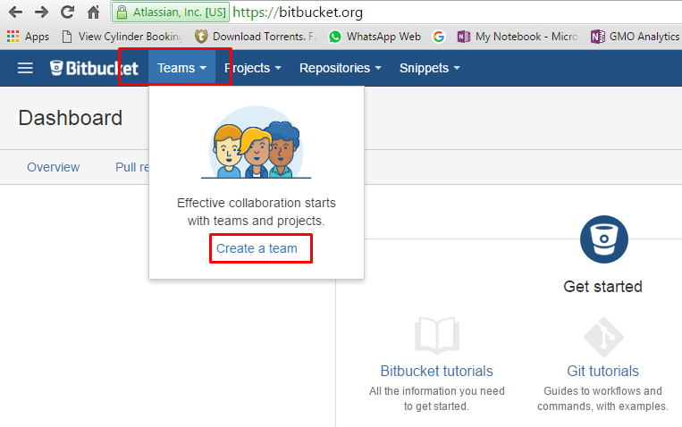

1. Enter team name and add the members

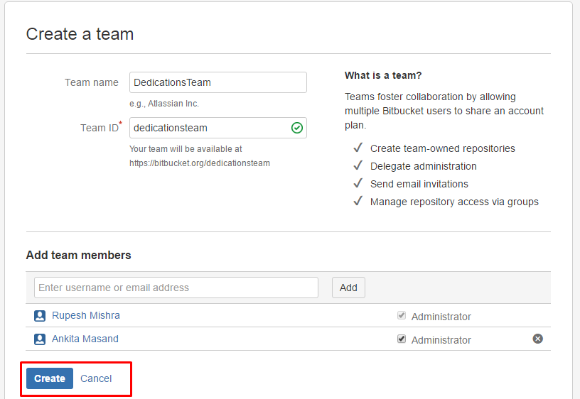

1. Create your repository

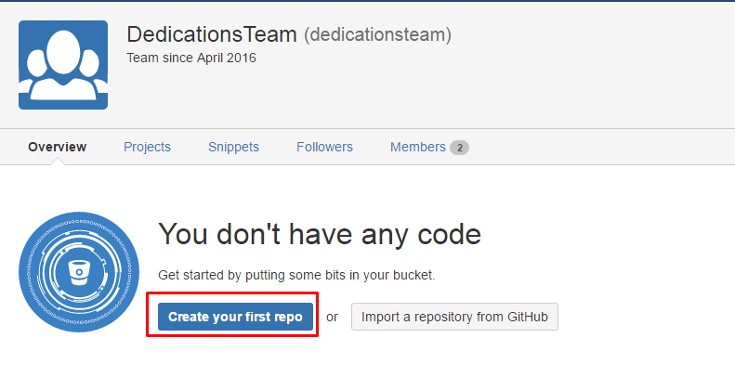

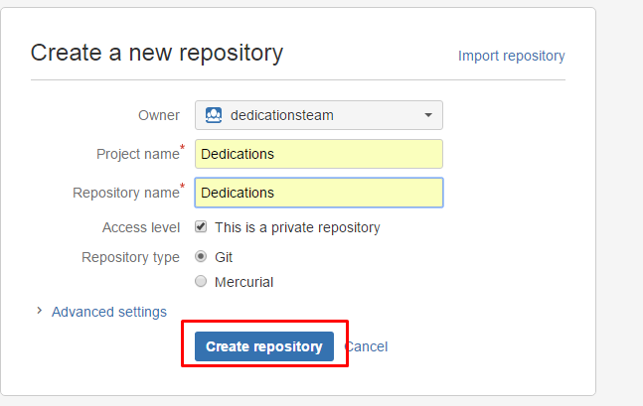

1. Clone your repository using Source Tree (Source tree must be installed before this)

Source tree applications will start after this step.

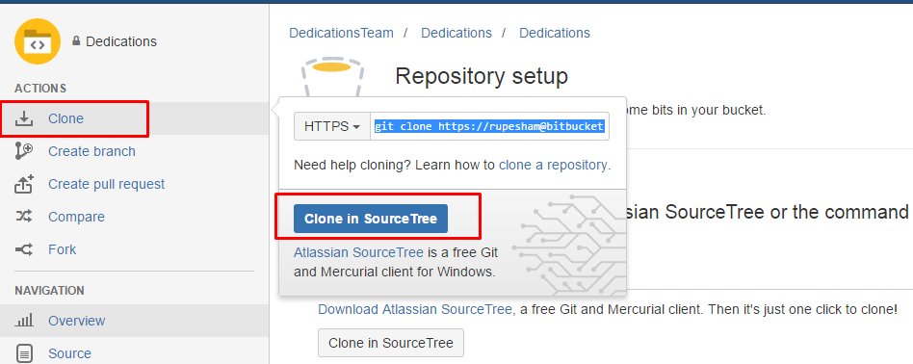

1. Select the destination path where you want to create the repository

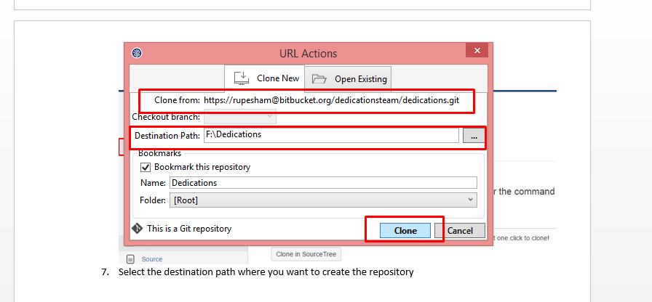

1. Create a folder with file inside your repository

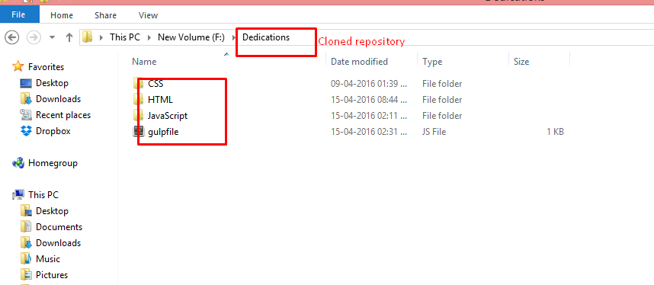

1. Files copied or created in the repository will appear in Source Tree

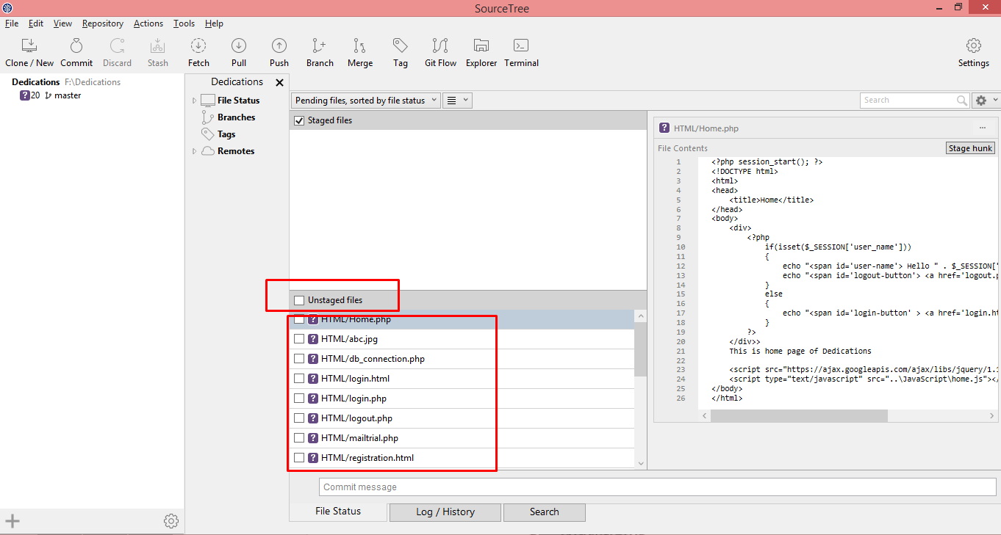

1. All these files are in the working directory.
2. Select the files which you want to commit

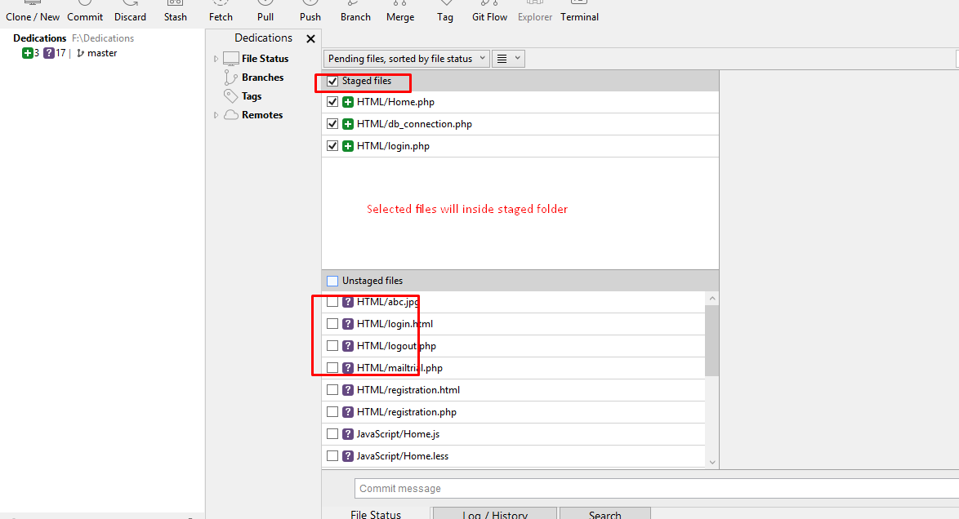

1. Click on commit

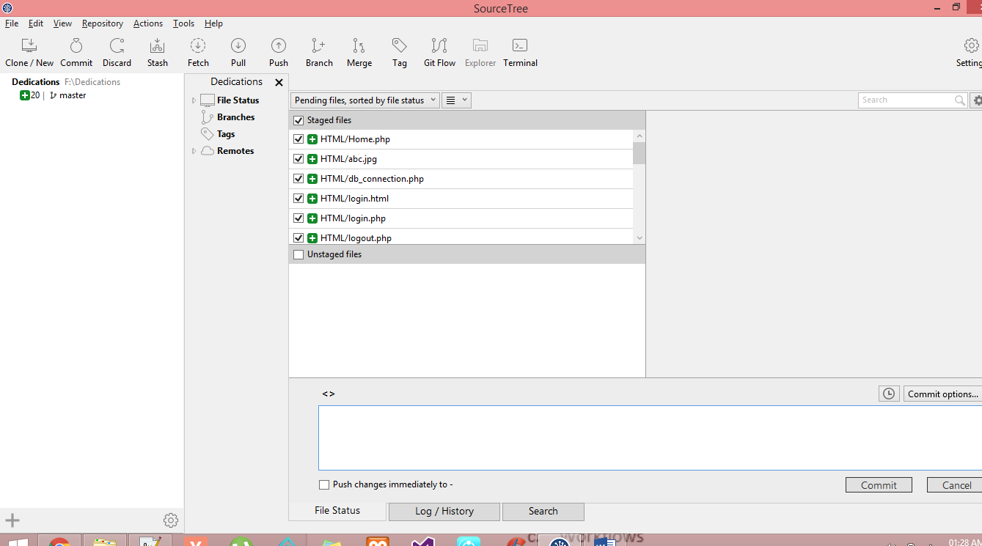

1. Click on Settings

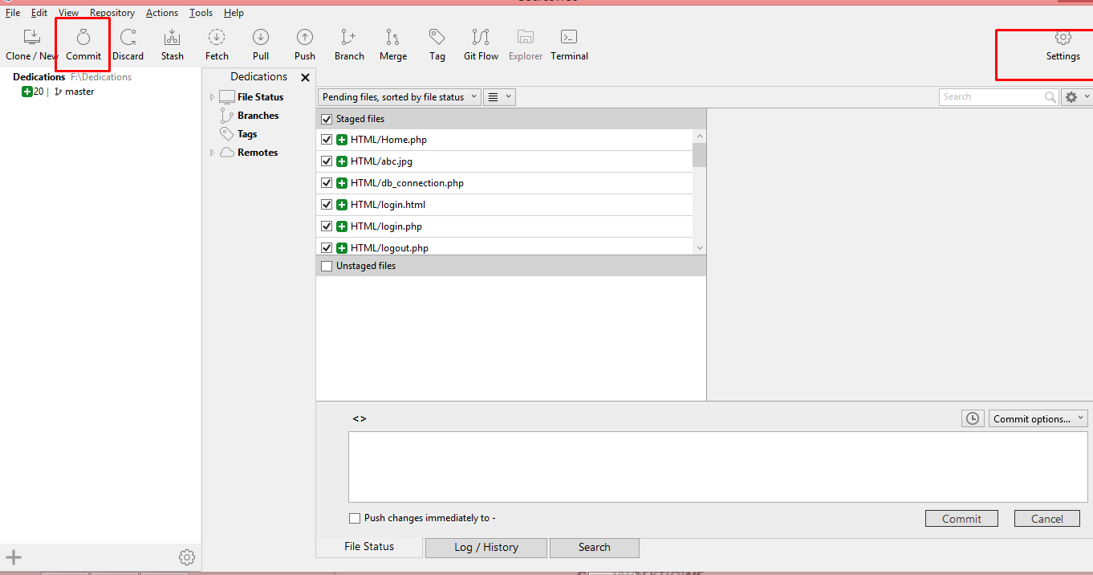

1. Click on Advanced tab
2. Uncheck global user settings
3. Enter your names and email id and click OK

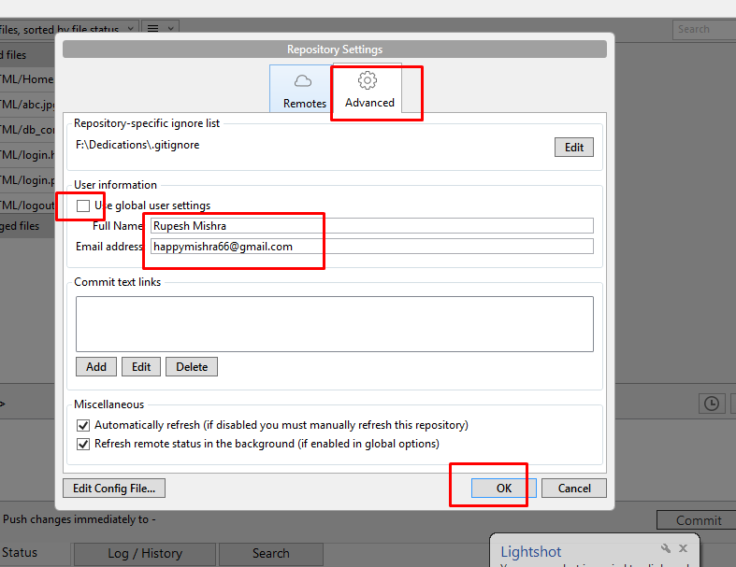

1. Enter comment in the text area and click commit

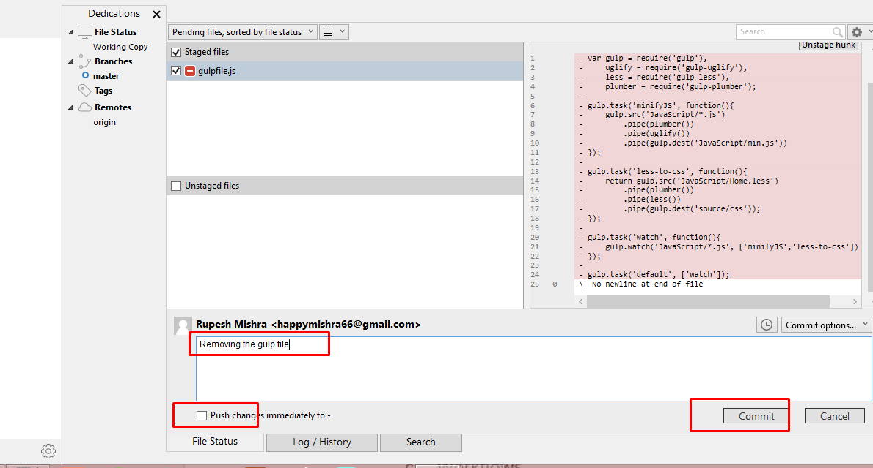

1. These files are committed on your local
2. To push them to the BitBucket server, click on create Push

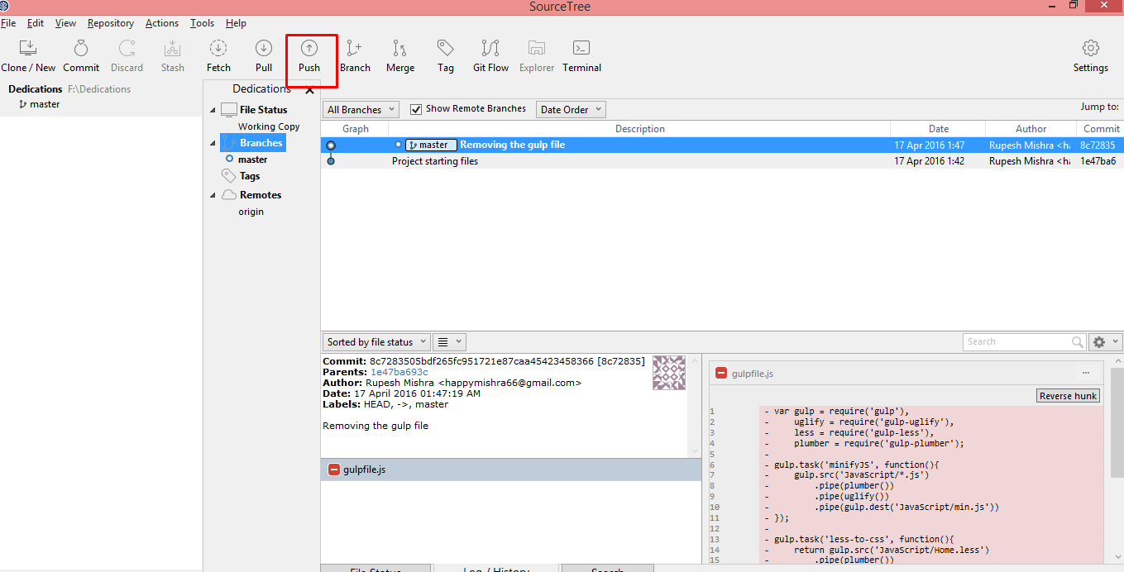

1. Go to your bit bucket website page and click on source, you will be able to see the modified file

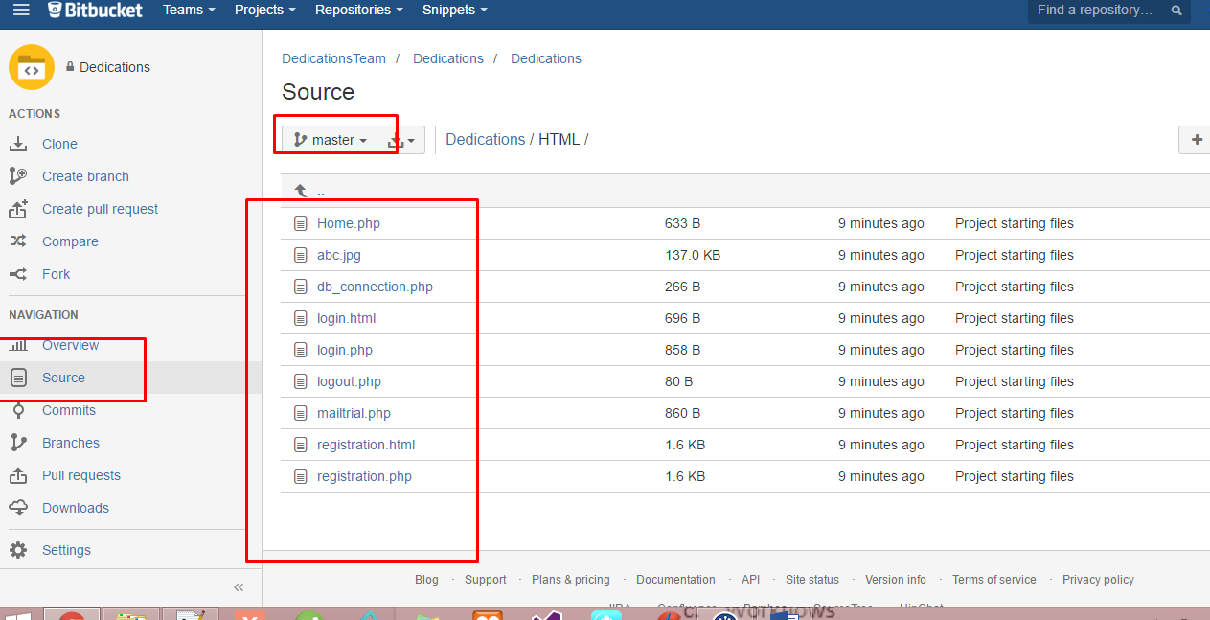

References: <https://www.youtube.com/watch?v=PkVMgh1q33Q>